WEEK 2
ZOHO CREATOR PLATFORM OVERVIEW

NITHIYA SREE N.C
241401060
Computer Science and Business Systems
Rajalakshmi Engineering College, Chennai

Introduction
This report documents a hands-on walkthrough of Zoho Creator, a low-code application development platform, carried out as part of the ongoing Student Leave Management System project. Each section below covers one area of the platform — from application building to governance and billing — paired with a screenshot taken directly from the workspace and a summary of what the section is used for.

1. Platform Overview
Zoho Creator is a low-code application development platform used to build custom business applications quickly. It combines a visual builder with scripting hooks, so teams can move fast on standard functionality while still dropping into code where the platform's defaults aren't enough.
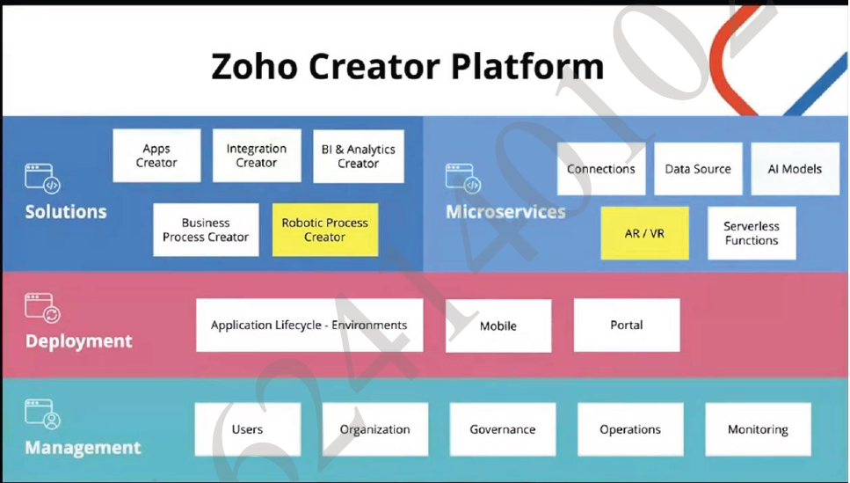
Figure 1. Zoho Creator platform overview.
- It provides application development, workflow automation, database management, integrations, and analytics.
- Users can create forms, reports, dashboards, and automated processes with minimal coding.
- Applications can be deployed across web and mobile platforms for convenient access.
- In this project, Zoho Creator is used to develop the Student Leave Management System with automated workflows and data management.

2. Application Dashboard
The Zoho Creator dashboard provides a central workspace for managing developed applications.
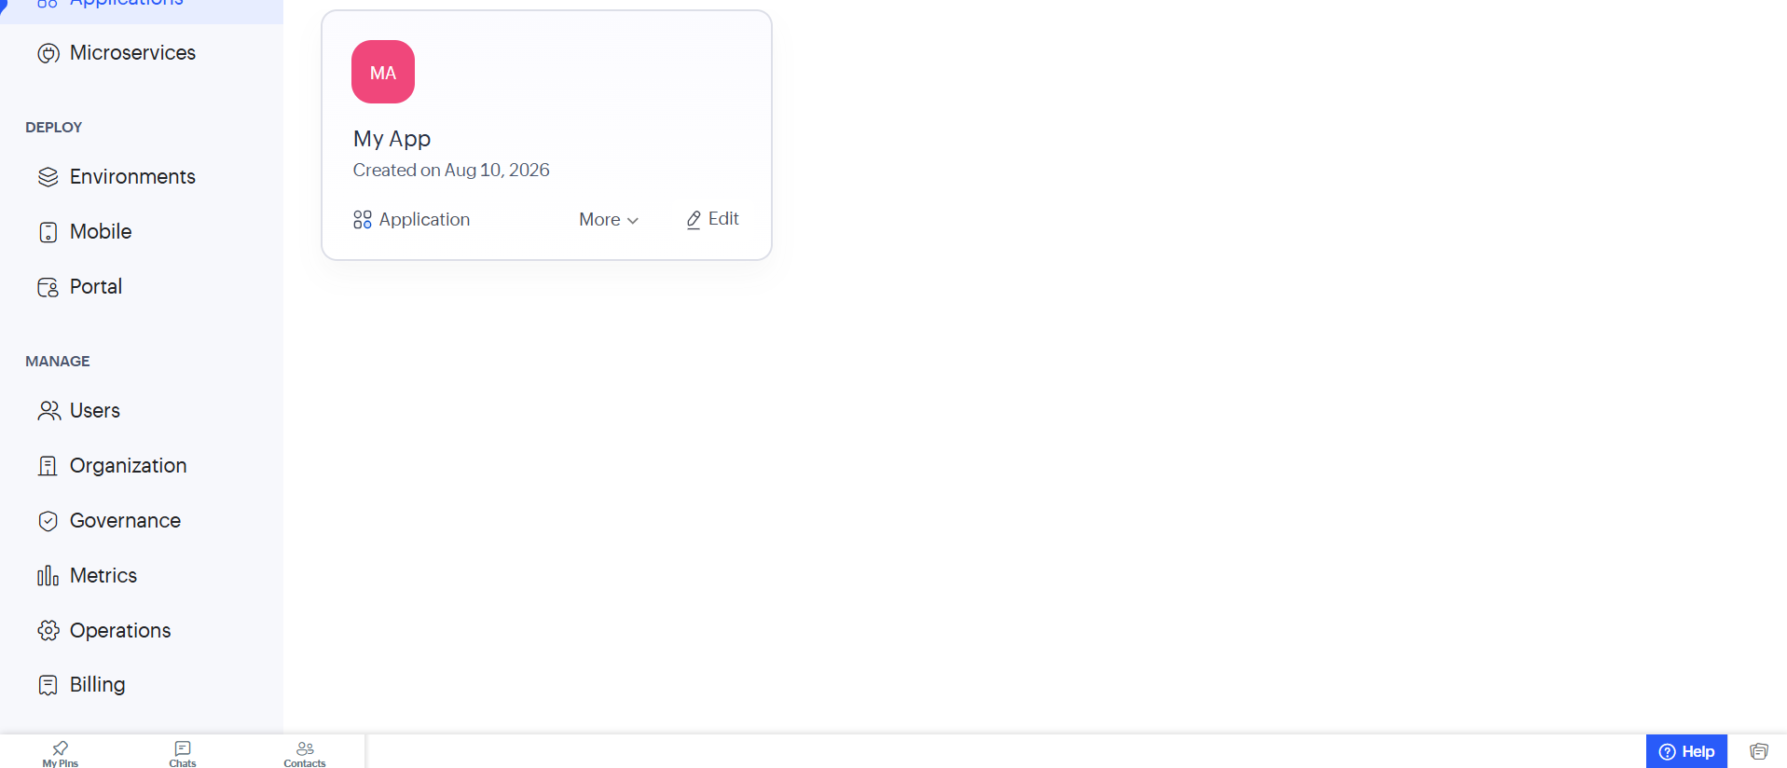
Figure 2. Application dashboard showing the created application.
- The Student Leave Management System is created and managed through the application dashboard.
- It provides options to edit, deploy, and manage application components.
- Drag-and-drop features simplify application development.
- Applications can be extended using workflows, reports, and user management features.

3. Environments
Zoho Creator supports separate environments for different stages of application development and deployment.
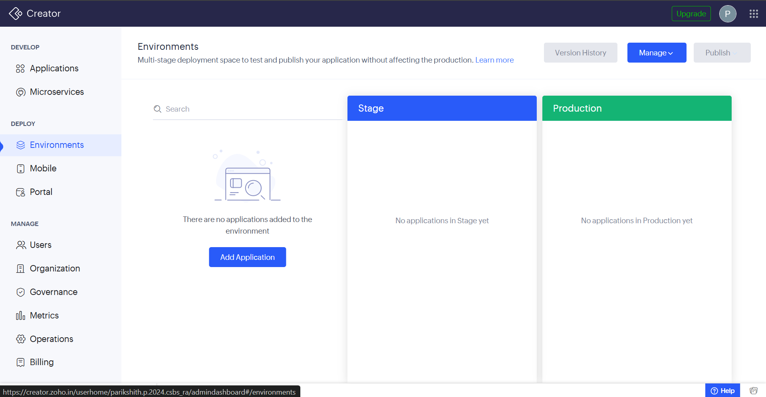
Figure 3. Environment configuration for application deployment.
- Dev, QA, and Production environments help separate development, testing, and live applications.
- Environment-specific settings, data sources, and integration endpoints can be managed independently.
- Environments can be cloned to replicate configurations for testing.
- Role-based access helps restrict users to appropriate environments.
- Separating experimental changes from production data reduces deployment risk.

4. Mobile
Zoho Creator provides features for configuring and accessing applications through mobile devices.
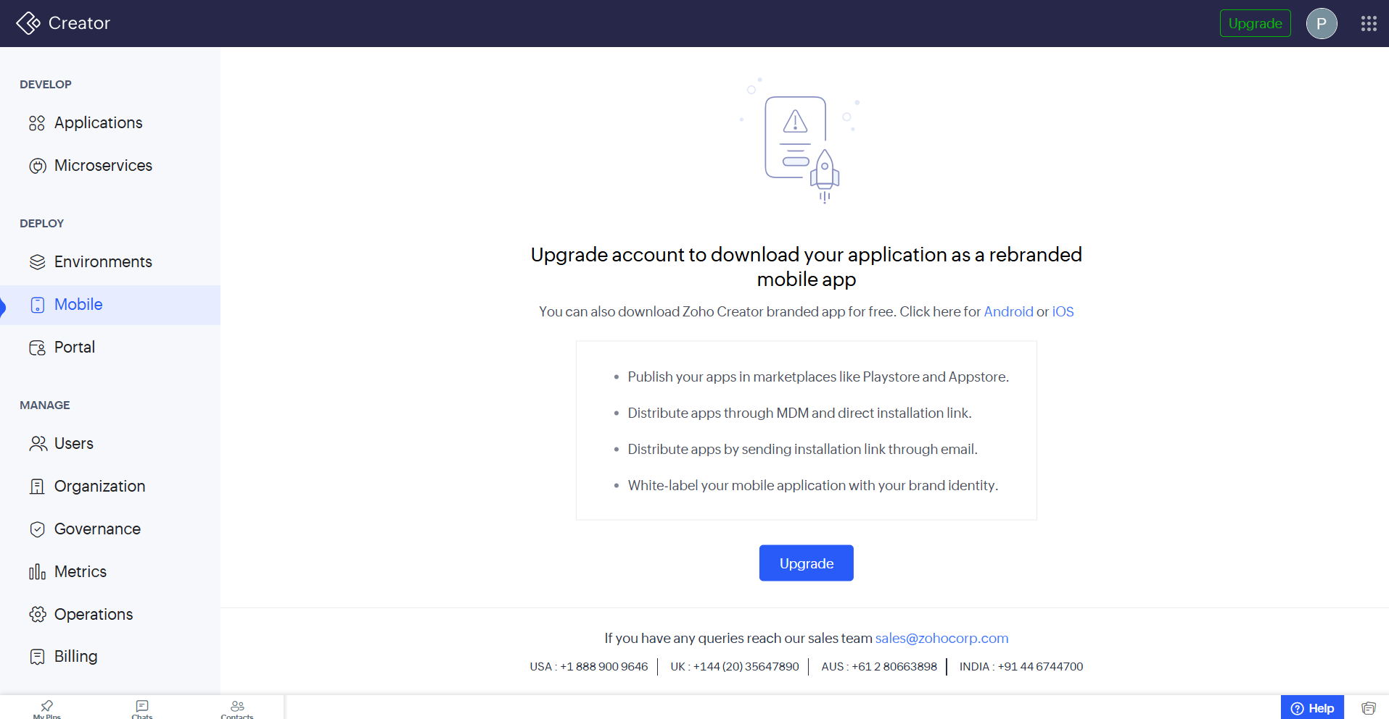
Figure 4. Mobile deployment and application configuration.
- Mobile layouts can be configured for phones and tablets.
- Forms and reports can be previewed for different screen sizes.
- Offline access and push notifications can support field users.
- Mobile-specific permissions can be applied for controlled access.
- This enables users to work with applications even when continuous connectivity is unavailable.

5. Portal
Zoho Creator portals provide external-facing access for customers, partners, vendors, or other users.
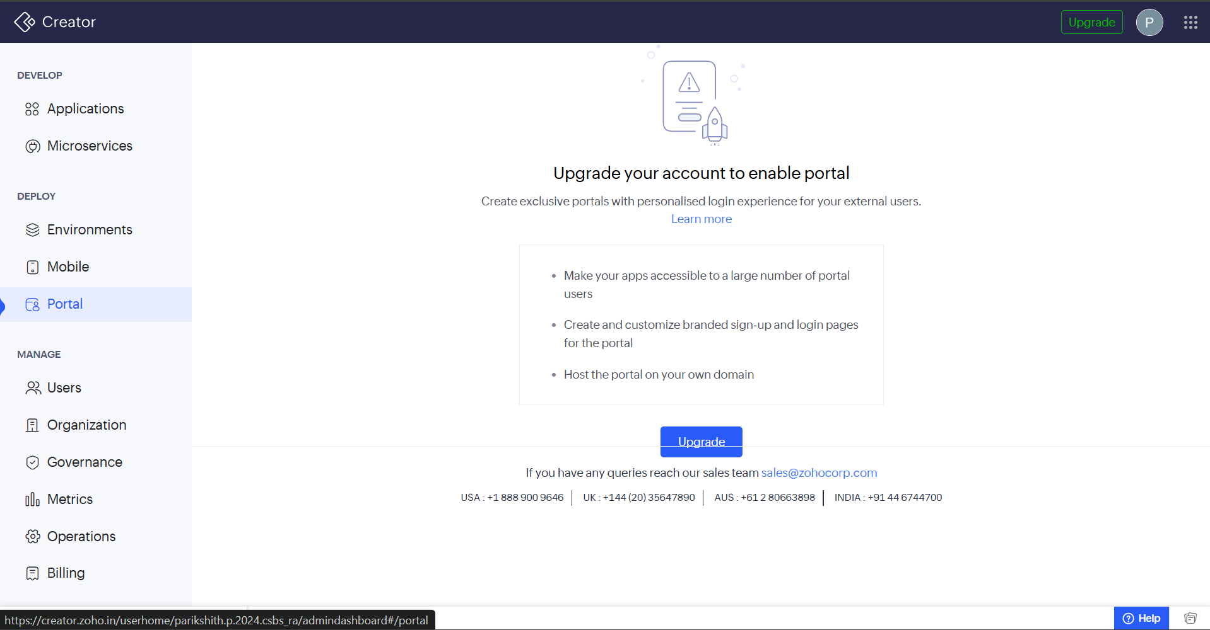
Figure 5. Portal configuration for external users.
- Portal branding, login methods, and visible application components can be customized.
- Portal users can be grouped with role-based access rights.
- Users can perform self-service activities such as submitting requests or checking information.
- Portals extend application access beyond internal employees while maintaining controlled access.

6. Users
The Users section manages access for internal users, external portal users, and public users.
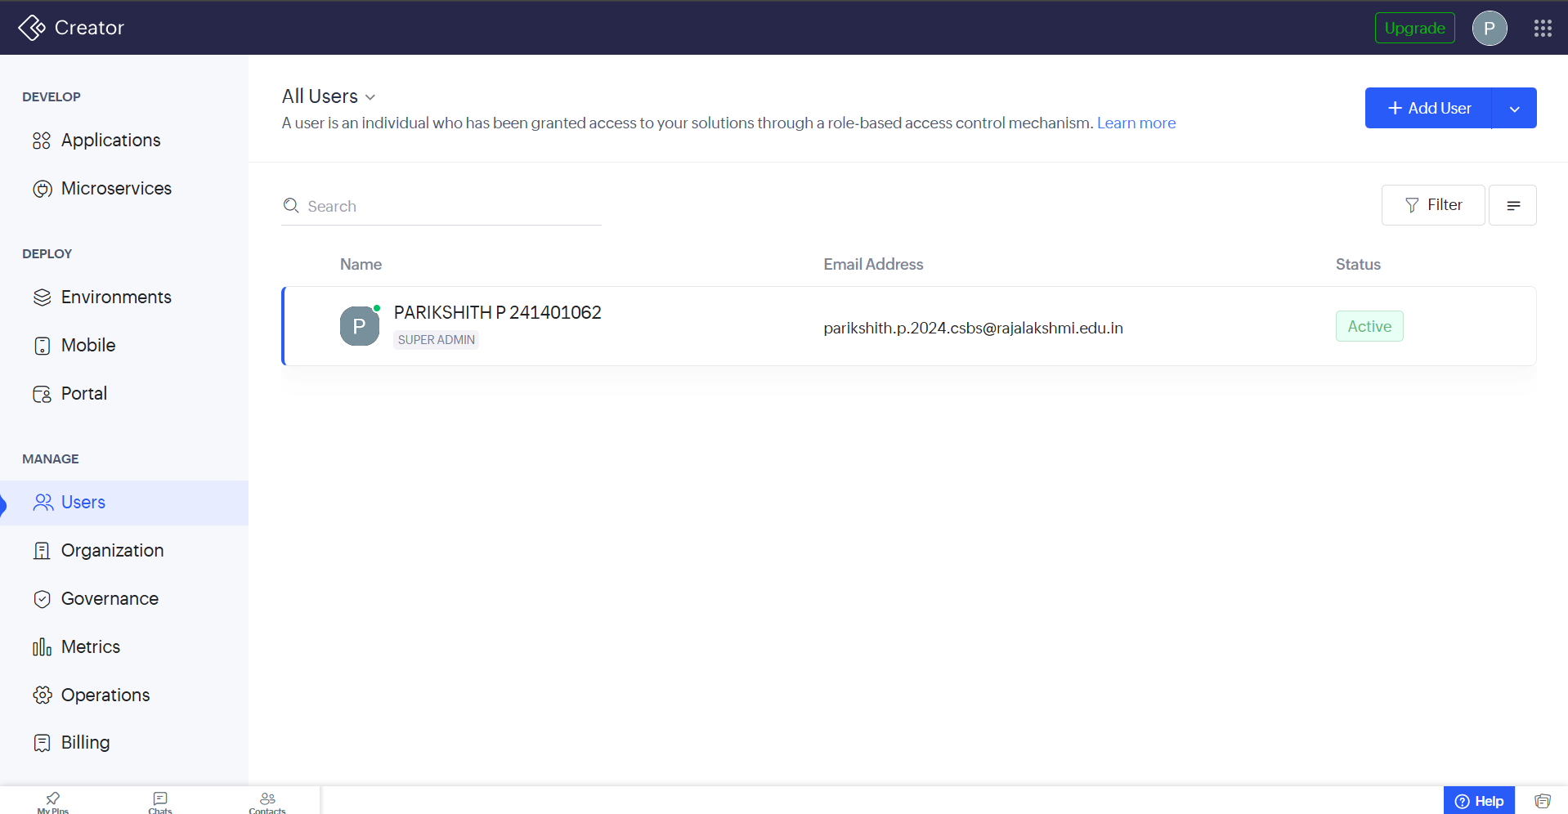
Figure 6. User management and access control.
- Users can be added manually or imported from directories.
- Role-based permissions control access to application features and data.
- Security options can include multi-factor authentication, IP restrictions, and session timeouts.
- User activity can be logged for compliance and security purposes.
- Effective user management ensures that access is provided according to responsibilities.

7. Organization
The Organization section represents the company structure and hierarchy within the platform.
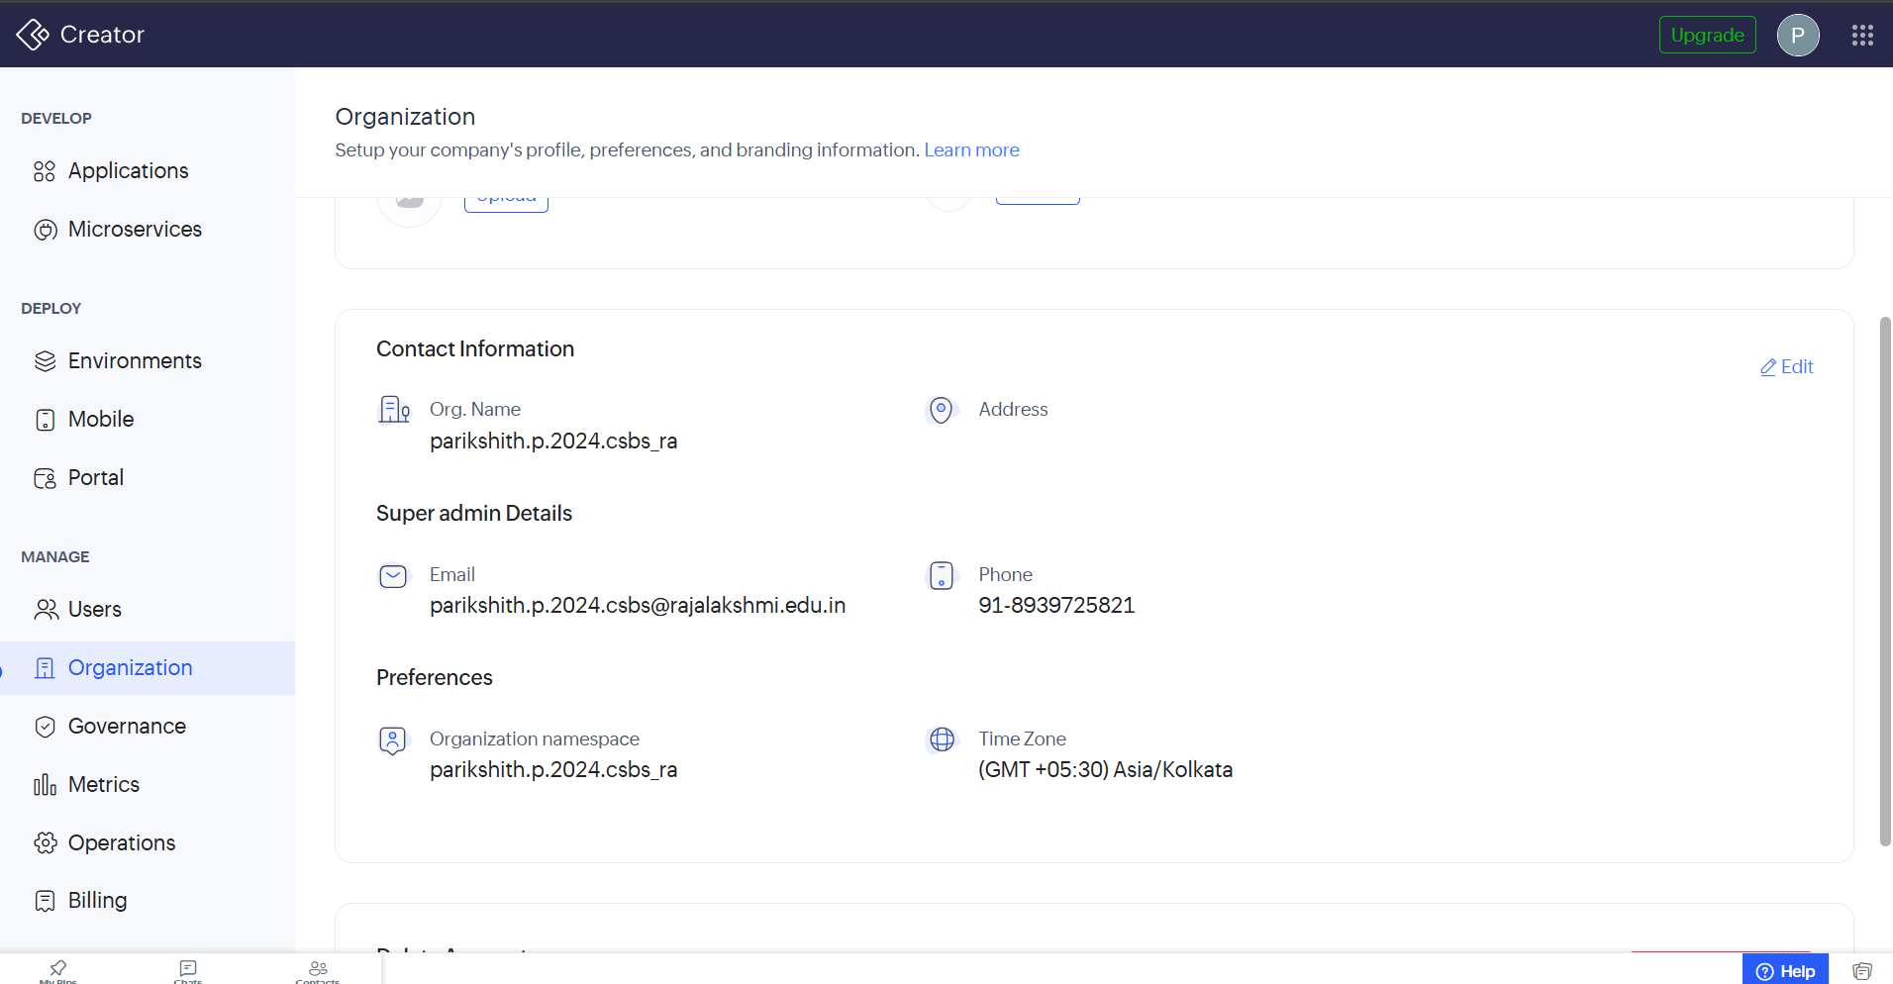
Figure 7. Organization settings and account structure.
- Departments, teams, and reporting relationships can be mapped.
- Organization structures can support data visibility and access rules.
- Record-level access and data filtering can be applied based on organizational requirements.
- Integration with identity-management services can support centralized control.
- The structure helps align application behavior with organizational roles.

8. Governance
Governance features help maintain development, data, security, and compliance standards across the workspace.
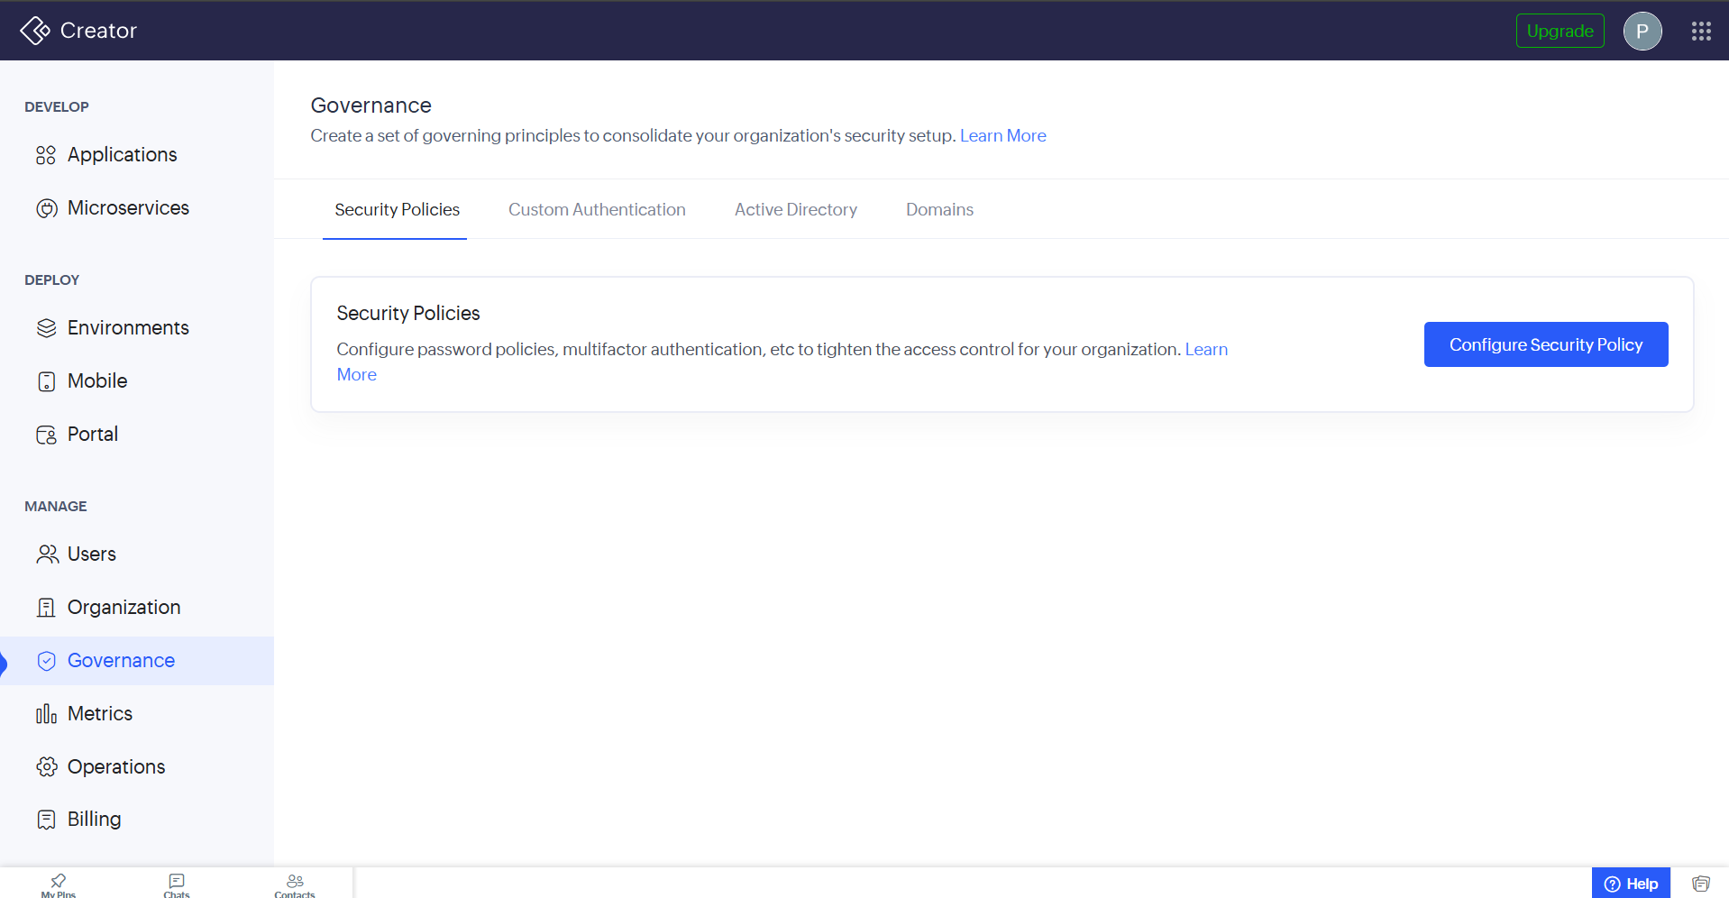
Figure 8. Governance and security policy configuration.
- Organizations can define policies for application naming, data retention, and integration approvals.
- Compliance checks can identify risky configurations or unapproved scripts.
- Audit trails can record changes to applications, workflows, and permissions.
- Governance controls help maintain consistent standards in enterprise deployments.
- These controls reduce operational and security risks.

9. Metrics
The Metrics section provides usage statistics and activity information for applications, users, and portals. No screenshot was captured for this section; the points below summarize its role in the platform.
- Charts can display form submissions, report views, and workflow executions.
- Data can be filtered by date range, user group, or application component.
- Portal activity can be tracked to understand external user engagement.
- Usage information can help identify areas for optimization.
- Metrics can also support evaluation of platform usage and resource requirements.

10. Operations
The Operations section helps monitor application health, integrations, background jobs, and workflow activity.
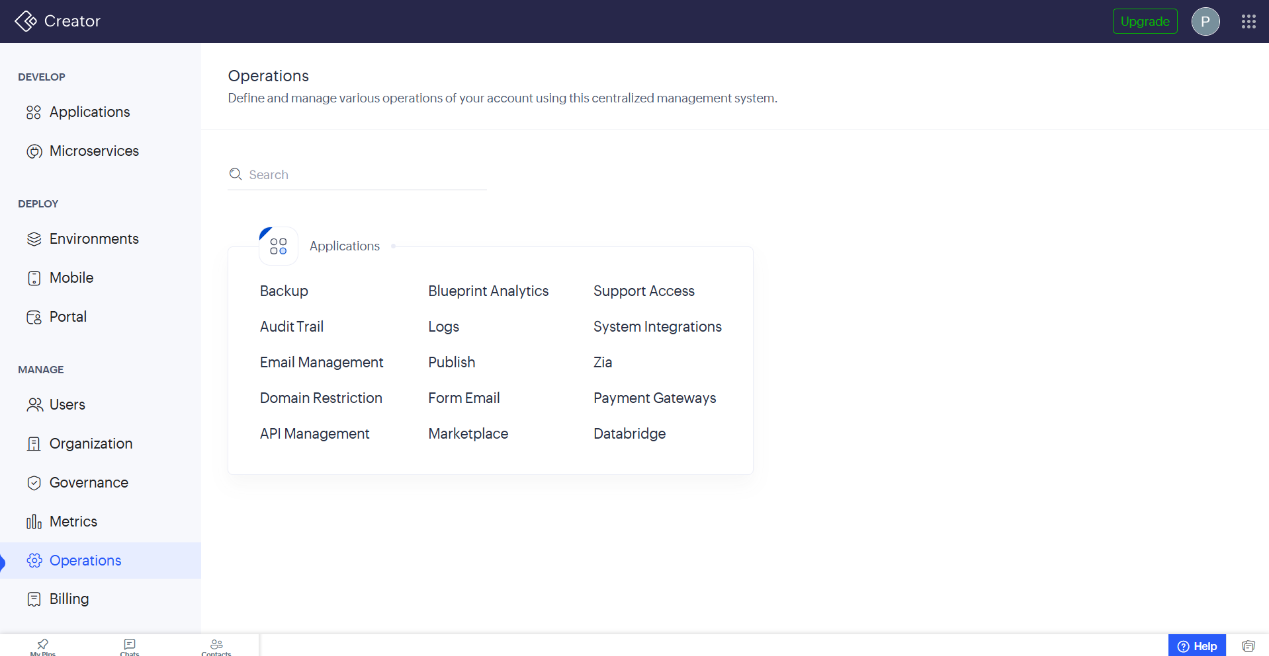
Figure 9. Operations and application management features.
- It displays the status of scheduled tasks, API connections, and data synchronization processes.
- Alerts can indicate failures, throttling, or quota-related issues.
- Failed workflows or processes can be investigated and re-run when supported.
- Operational monitoring reduces manual troubleshooting and helps maintain application availability.

11. Billing
The Billing section manages Zoho Creator subscription and usage-related charges. No screenshot was captured for this section; the points below summarize its role in the platform.
- It displays plan details, add-on costs, and invoice information.
- Organizations can manage subscription tiers, user licenses, and storage requirements.
- Usage meters can show consumption of applications, records, and API calls against available quotas.
- Billing information provides visibility and control over platform spending.

Summary
Together, these sections cover the full lifecycle of an application built on Zoho Creator — from initial design in the dashboard, through environment separation and mobile/portal delivery, to the ongoing governance, monitoring, and billing needed to run it responsibly. For the Student Leave Management System, this maps directly onto the workflow of designing leave-request forms, automating approval routing, controlling who can submit or approve requests, and keeping an eye on usage as more students and staff come onto the system.

